Deploying Dynamics 365
Finance & Supply Chain Management
via PPAC
Environment provisioning guide for the Unified Administration experience
UDE • USE
Craig Leska
Senior Dynamics 365 Technical & Solutions Architect
Logan Consulting
September 2026

Contents
1. Purpose and Scope 3
2. Environment Types 3
3. Prerequisites 3
4. Provisioning a Finance and Operations UDE Environment in PPAC 3
4.1 UDE prerequisites 4
4.2 Validate the cloud environment 7
4.3 Configure the local developer workstation 7
4.4 Validate the development loop 7
4.5 UDE deployment completion checklist 8
UDE architecture note 8
5. Deploying a Unified Sandbox Environment (USE) 8
5.1 USE prerequisites 9
USE Provisioning choices 11
6. Recommended Environment Pattern 12
7. PPAC vs. Legacy LCS Operating Model 12
8. Implementation Checklist 12
9. Operational Notes 13
10. Sources and Further Reading 13

1. Purpose and Scope
This guide documents the current Power Platform admin center (PPAC) approach for provisioning Dynamics 365 Finance and Supply Chain Management environments. It is intended as a practical implementation and administration reference rather than a reproduction of the source article.
Microsoft is moving finance and operations application lifecycle administration toward the Power Platform. Microsoft Learn notes that, as part of the One Dynamics One Platform effort, some Lifecycle Services (LCS) features have been deprecated. Newer environment administration workflows therefore increasingly take place in PPAC.

2. Environment Types
Environment | Meaning | Primary Use | Developer Tools
UDE | Unified Developer Environment | X++ coding and extension development; source control | Enabled
USE | Unified Sandbox Environment | UAT, testing, configuration, integrations and demo/process validation | Normally disabled
UPE | Unified Production Environment | Live production workload | Not used for development

Scope note: This guide covers the provisioning and configuration of Unified Developer Environments (UDE) and Unified Sandbox Environments (USE) through the Power Platform admin center (PPAC). Unified Production Environment (UPE) provisioning is outside the scope of this guide and will be addressed in upcoming documentation.
Key distinction: Do not enable developer tooling merely because an environment is non-production. A USE is for validation and testing; a UDE is specifically for X++ coding and extension development.

3. Prerequisites
- Appropriate Power Platform / Dynamics 365 administrative permissions.
- A valid Dynamics 365 Finance or Supply Chain Management entitlement for the tenant.
- A planned environment name, region, security group strategy and environment group.
- Decision on whether the environment will contain demo data.
- Decision on whether developer tools are required. Enable them for a UDE, not for a normal USE.
- Recommended: use a dedicated administrative/service identity for provisioning rather than tying the environment lifecycle to an individual consultant account. For example, use an account such as D365Deploy@Contoso.com.

4. Provisioning a Finance and Operations UDE Environment in PPAC
A Unified Developer Environment (UDE) is a Power Platform Sandbox provisioned specifically for X++ development. Microsoft positions UDE as the replacement for LCS-hosted developer virtual machines. It is intended for a single developer, is limited to one AOS instance, and does not provide elastic compute scaling. A UDE and USE cannot be converted into one another after provisioning.

4.1 UDE prerequisites
- A Dynamics 365 Finance or Supply Chain Management license/entitlement that permits environment provisioning.
- Power Platform administrative rights sufficient to create and configure the environment.
- The developer account assigned the System Administrator role in the target environment.
- A Windows 10 or Windows 11 developer workstation with Visual Studio 2022 or 2026.
- Visual Studio installed with the .NET desktop development workload and the required modeling/SDK components.
- At least 16 GB of free space on the local system drive for Finance and Operations extensions and metadata.
- Microsoft SQL Server Express LocalDB available and accessible using Windows authentication.
- A source-control repository and branch strategy. Azure DevOps Git or another supported version-control approach should be established before regular development begins.
Step 1 - Create the Power Platform environment
- Open the Power Platform admin center and go to Manage / Environments.
- Select New.
- Enter the environment name and select the required region.
- Set Type to Sandbox, select the appropriate Region, and enter an environment Name. Expand Change default settings, leave Environment group set to None, and set Add a Dataverse data store to Yes. The remaining default settings can remain Off.
Note: Select Sandbox as the Type even when creating a development environment. In Power Platform, Sandbox defines the environment type; the environment becomes a Unified Developer Environment (UDE) later when Finance and Operations developer tools are enabled.

- Click Next and set language and currency. Select a security group; None is default, define a custom URL and Enable Dynamics 365 apps to Yes. The D365 apps will be deployed in later steps.
- Click Save when finished to begin deployment of the Power Platform environment.
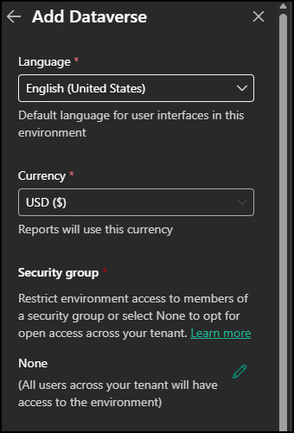 | 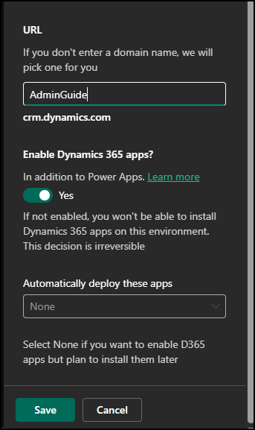

Step 2 - Wait for the base environment to become ready
Allow PPAC to finish creating the Dataverse/Power Platform environment before installing the Finance and Operations components. Confirm that the environment opens normally and that the expected region, type and security configuration are correct before continuing.
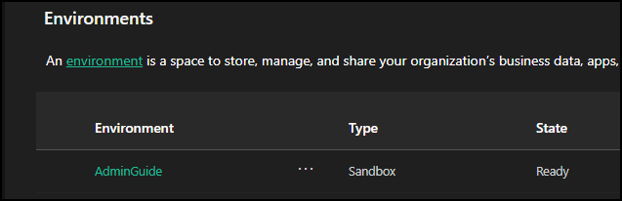
Step 3 - Install Finance and Operations Platform Tools
- Open the environment in PPAC.
- Navigate to Resources / Dynamics 365 apps (the exact PPAC navigation may change over time as Microsoft updates the admin center).
- Locate Dynamics 365 Finance and Operations Platform Tools.
Note: Multiple entries for Dynamics 365 Finance and Operations Platform Tools may appear in the list. If duplicate entries are displayed, select either one.
- Install the application, agree to the terms and wait for the installation to complete.
Platform Tools lays the required platform foundation in the Power Platform environment before the Finance and Operations application is provisioned.
A notification banner at the top of the page indicates that the application is being installed. Installation typically takes approximately 5-15 minutes. Refresh the environment periodically to check the installation status. 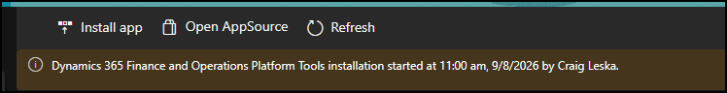
Step 4 - Install the Finance and Operations Provisioning App
- Return to the Dynamics 365 apps list for the environment.
- Locate the Dynamics 365 Finance and Operations Provisioning App.
Note: Multiple entries for Dynamics 365 Finance and Operations Provisioning App may appear in the list. When provisioning a new Finance and Operations environment, select an entry with a status of Not Configured.
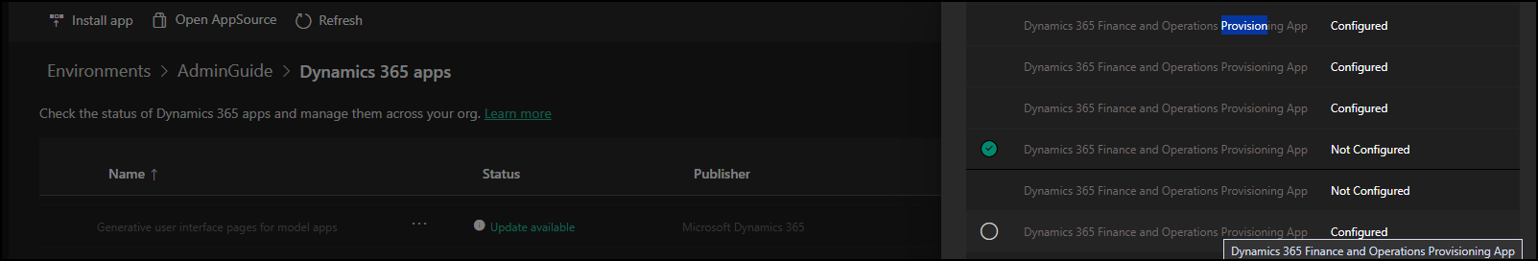
- Click Next to start the installation.
- Choose the required Finance and Operations application/version options.
- Choose whether Developer Tools should be enabled.
- Choose whether demo data should be loaded.
- Submit the provisioning request and monitor the installation until it completes. Provisioning may take a couple of hours or longer. Do not assume the installation has failed simply because it remains in progress for an extended period.

Settings | Version | Review and install
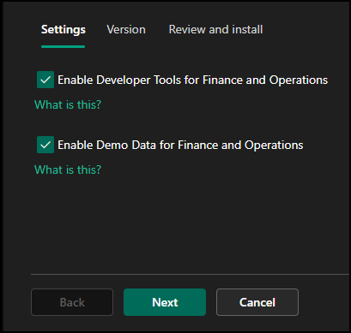 | 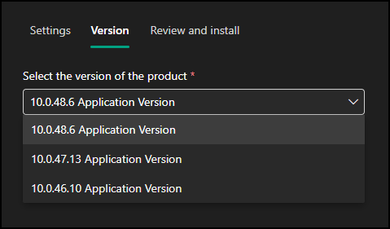 | 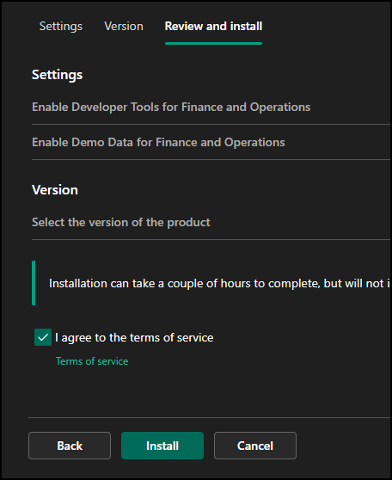
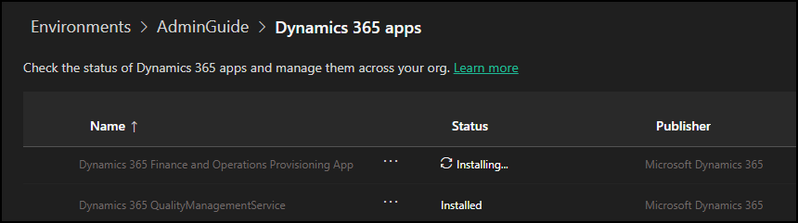

UDE Provisioning choices
Option | UDE Recommendation | USE / UAT Recommendation
Developer Tools | Enable | Leave unchecked
Demo Data | Optional; generally not required | Enable for demo/training/process-validation environments; normally disable for client UAT
Application Version | Keep aligned with the development/build strategy | Select the implementation-supported version

4.2 Validate the cloud environment
- Open the Finance and Operations URL and confirm that the application starts successfully.
- Sign in with the developer account and confirm the account has the System Administrator role.
- Record the environment URL, environment ID, region, installed application/version, and assigned developer.
- Confirm the environment is being used as a single-developer environment; do not use UDE as a shared development server or performance-test environment.
- If database access is required for development, use the supported just-in-time product database credential process rather than maintaining permanent SQL credentials.

4.3 Configure the local developer workstation
Step 5 - Install Power Platform Tools for Visual Studio
- Open Visual Studio and install the Microsoft Power Platform Tools extension.
- Restart Visual Studio after the extension installation completes.
- Connect Power Platform Tools to the tenant and select the newly provisioned UDE.
Step 6 - Download the Finance and Operations extension and metadata
- After Visual Studio connects to the UDE, allow Power Platform Tools to download the Finance and Operations Visual Studio extension and application metadata.
- Leave Auto setup for Dynamics 365 enabled for the normal setup path. The tooling automatically extracts/configures metadata and completes the local configuration.
- Monitor the Visual Studio Output window for prompts, download status, database synchronization messages, or required user actions.
- Confirm the Dynamics 365 menu is available in Visual Studio after configuration finishes.
Step 7 - Configure source control
- Clone or connect to the project source-control repository on the developer workstation.
- Use the project-defined branch for the UDE and ensure the local metadata/source tree is synchronized with source control before deploying changes.
- Commit and push X++ changes through source control rather than treating the UDE runtime as the authoritative copy of code.
Microsoft strongly recommends version control for UDE work because switching branches, using multiple development machines, or deploying inconsistent metadata can leave the cloud environment out of sync with the local development state.

4.4 Validate the development loop
Step 8 - Compile, deploy, synchronize, and debug a test change
- Open or create the project/model used for the implementation and perform a compile/build in Visual Studio.
- Deploy the metadata/code to the connected UDE cloud runtime using the Dynamics 365 / Power Platform development tooling.
- Run database synchronization when the change requires schema synchronization.
- Open the Finance and Operations application and validate that the deployed change is available.
- Set a breakpoint and perform a basic debugging test to confirm the local Visual Studio session can debug code executing in the UDE cloud runtime.
- Commit the validated change to source control according to the project branching and pull-request policy.

4.5 UDE deployment completion checklist
- Power Platform Sandbox created in the correct region and environment group
- Finance and Operations Platform Tools installed
- Finance and Operations Provisioning App installed
- Enable Developer Tools for Finance and Operations selected during provisioning
- Finance and Operations URL opens successfully
- Developer assigned System Administrator
- Visual Studio 2022/26 prerequisites installed
- Power Platform Tools connected to the UDE
- Finance and Operations Visual Studio extension and metadata downloaded
- Source-control repository configured
- Test X++ build and deployment completed
- Database synchronization tested if applicable
- Debugger connectivity validated
- Environment details and ownership documented

UDE architecture note
With UDE, the development and execution tiers are separated. X++ source code and Finance and Operations metadata are maintained on the developer workstation, while the Finance and Operations application runtime and business database execute in the cloud UDE. Code must therefore be deployed from Visual Studio to the connected cloud environment before it can run or be debugged there.

5. Deploying a Unified Sandbox Environment (USE)
A Unified Sandbox Environment (USE) is a Power Platform Sandbox provisioned with Dynamics 365 Finance and Operations for testing, configuration, integration, training, and other non-production workloads. Unlike a Unified Developer Environment (UDE), a USE does not have Finance and Operations developer tools enabled and is not intended for X++ development.
USE environments replace the traditional LCS-hosted Tier 2 and higher sandbox environments for many implementation and testing scenarios. They are managed through the Power Platform admin center (PPAC) and can support production-like testing without providing a developer workstation or X++ development capability.
A USE cannot be converted to a UDE after provisioning; the intended environment type should therefore be determined before the Finance and Operations application is provisioned.

Note: The provisioning process for a USE is similar to provisioning a UDE. The key difference is that Enable Developer Tools for Finance and Operations must remain disabled.

5.1 USE prerequisites
- A Dynamics 365 Finance or Supply Chain Management license/entitlement that permits environment provisioning.
- Power Platform administrative rights sufficient to create and configure the environment.

Step 1 - Create the Power Platform environment
- Open the Power Platform admin center and go to Manage / Environments.
- Select New.
- Enter the environment name and select the required region.
- Set Type to Sandbox, select the appropriate Region, and enter an environment Name. Expand Change default settings, leave Environment group set to None, and set Add a Dataverse data store to Yes. The remaining default settings can remain Off.
Note: Select Sandbox as the Type when creating a USE. The Finance and Operations provisioning options later determine whether the environment is configured as a UDE or USE.

- Click Next and set language and currency. Select a security group; None is default, define a custom URL and Enable Dynamics 365 apps to Yes. The D365 apps will be deployed in later steps.
- Click Save when finished to begin deployment of the Power Platform environment.
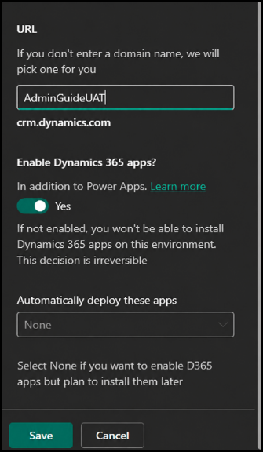

Step 2 - Wait for the base environment to become ready
Allow PPAC to finish creating the Dataverse/Power Platform environment before installing the Finance and Operations components. Confirm that the environment opens normally and that the expected region, type and security configuration are correct before continuing.
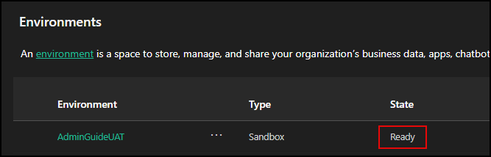
Step 3 - Install Finance and Operations Platform Tools
- Open the environment in PPAC.
- Navigate to Resources / Dynamics 365 apps (the exact PPAC navigation may change over time as Microsoft updates the admin center).
- Locate Dynamics 365 Finance and Operations Platform Tools.
Note: Multiple entries for Dynamics 365 Finance and Operations Platform Tools may appear in the list. If duplicate entries are displayed, select either one.
- Install the application, agree to the terms and wait for the installation to complete.
Platform Tools lays the required platform foundation in the Power Platform environment before the Finance and Operations application is provisioned.
A notification banner at the top of the page indicates that the application is being installed. Installation typically takes approximately 5-15 minutes. Refresh the environment periodically to check the installation status.
Step 4 - Install the Finance and Operations Provisioning App
- Return to the Dynamics 365 apps list for the environment.
- Locate the Dynamics 365 Finance and Operations Provisioning App.
Note: Multiple entries for Dynamics 365 Finance and Operations Provisioning App may appear in the list. When provisioning a new Finance and Operations environment, select an entry with a status of Not Configured.
- Click Next to start the installation.
- Choose the required Finance and Operations application/version options.
- Leave Enable Developer Tools unchecked.
- Choose whether demo data should be loaded. For a UAT environment, normally leave Enable Demo Data for Finance and Operations unchecked. Enable demo data only when appropriate for demo, training, or process-validation environments.
- Submit the provisioning request and monitor the installation until it completes. Provisioning may take a couple of hours or longer. Do not assume the installation has failed simply because it remains in progress for an extended period.

Settings | Version | Review and install
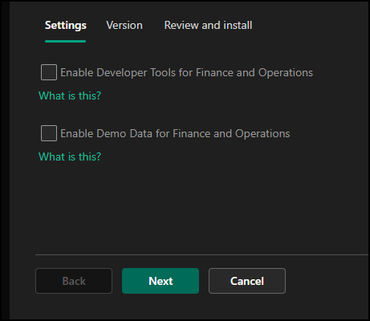 | 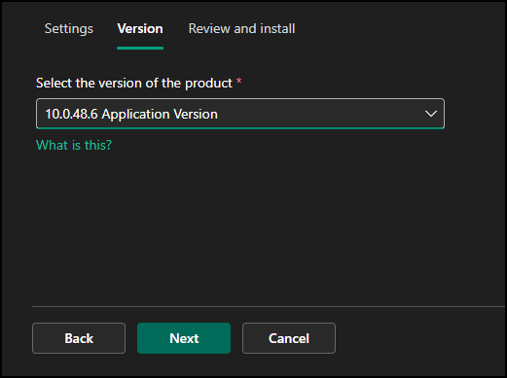 | 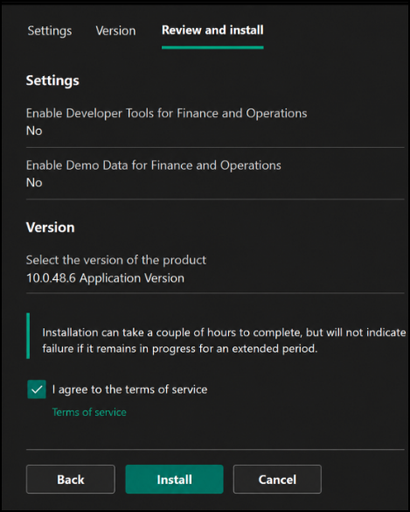
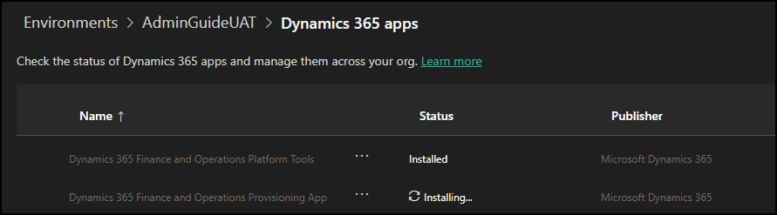

USE Provisioning choices
Option | USE / UAT Recommendation | UDE Recommendation
Developer Tools | Leave unchecked | Enabled
Demo Data | Enable for demo/training/process-validation environments; normally disable for client UAT | Optional; generally not required
Application Version | Select the implementation-supported version | Keep aligned with the development/build strategy

6. Recommended Environment Pattern
A typical implementation should separate development from functional testing and production. The exact topology depends on project size, release cadence and customer requirements.
Stage | PPAC Type | Purpose | Typical Change Flow
DEV | UDE | X++ coding, extensions, unit testing | Source control → build/package
TEST / QA | USE | Technical and functional validation | Deploy validated package
UAT | USE | Business acceptance, integrations, regression testing | Promote release candidate
PROD | UPE | Live business operations | Deploy approved production release

7. PPAC vs. Legacy LCS Operating Model
The important change is not simply that Microsoft moved buttons from one portal to another. Finance and Operations environments are becoming part of the broader Power Platform environment lifecycle. Provisioning, capacity, application installation and administration are increasingly centered in PPAC, while legacy LCS capabilities are being reduced or transitioned.
- Environment creation and application installation are managed through PPAC.
- UDE replaces the traditional developer VM model for the unified development experience.
- USE provides the unified sandbox model for UAT/testing/configuration.
- UPE is the unified production environment.
- Capacity and Power Platform administration become more important than the historical Tier 2 add-on model.
- Existing LCS projects and features may still matter during the transition; do not assume every legacy function has disappeared at once.

8. Implementation Checklist
- Environment purpose identified (UDE, USE or UPE)
- Region and environment group confirmed
- Administrative/service identity confirmed
- Required licenses/entitlements confirmed
- Base Power Platform environment created
- Dynamics 365 apps enabled
- Finance and Operations Platform Tools installed
- Finance and Operations Provisioning App installed
- Developer Tools choice validated
- Demo Data choice validated
- Finance and Operations application opens successfully
- Users/security validated
- Application/platform version recorded
- Integration requirements validated
- Source control/deployment path validated
- Update and maintenance ownership documented

9. Operational Notes
Provisioning time. The Finance and Operations Provisioning App can take a significant amount of time to complete. Do not treat a long-running install as failed unless PPAC reports an error or the status stops progressing for an abnormal period.
Demo data. Demo data is useful for training, demonstrations and process validation. It should not be enabled automatically for a customer UAT environment that is intended to receive customer configuration/data.
Portal changes. PPAC navigation and labels are evolving. Use the application names in this guide as the anchor when the exact menu location changes.
Transition period. Microsoft continues to transition Finance and Operations lifecycle features away from LCS. For client procedures, verify any high-impact deployment, servicing or production-management step against current Microsoft Learn documentation.

10. Sources and Further Reading
Microsoft platform-transition reference: Microsoft Learn, “Lifecycle Services resources,” updated March 10, 2026.
This guide paraphrases and reorganizes the deployment process into an implementation-oriented operating document.
Microsoft UDE references: Microsoft Learn documentation for unified environment types, development tools, the Finance and Operations Provisioning app, and the X++ development/deployment workflow.

Unified environment types and templates for finance and operations apps

Tutorial: Install the Finance and Operations Provisioning app

Install and configure development tools

Tutorial: Write, deploy, and debug X++ code

